Data Set Summary & Exploration

**1. Provide a basic summary of the data set. In the code, the analysis should be done using python, numpy and/or pandas methods rather than hardcoding results manually.**

The size of training set is 34799.

The size of the validation set is 4410。

The size of test set is 12640

The shape of a traffic sign image is (32, 32, 3)

The number of unique classes/labels in the data set is 43

2. Include an exploratory visualization of the dataset.

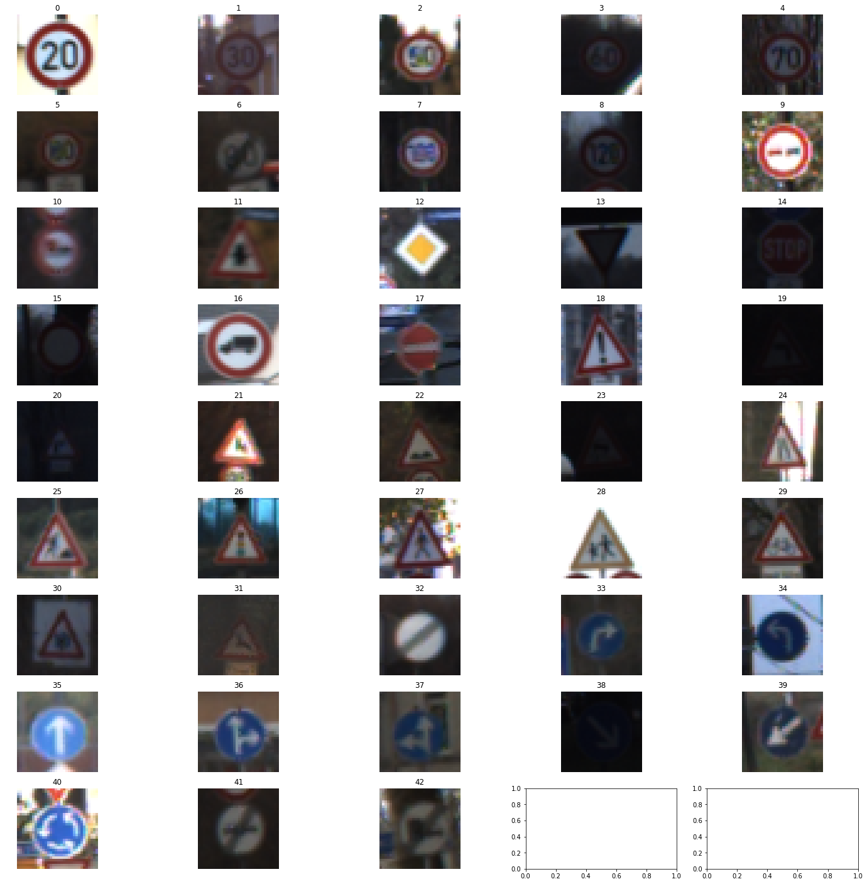

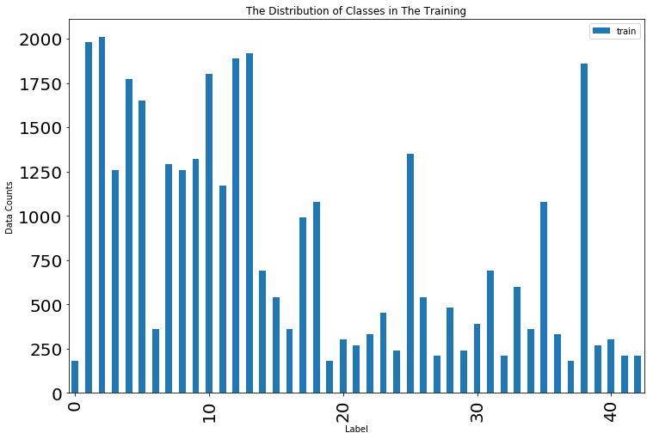

Design and Test a Model Architecture

1. Describe how you preprocessed the image data. What techniques were chosen and why did you choose these techniques? Consider including images showing the output of each preprocessing technique. Pre-processing refers to techniques such as converting to grayscale, normalization, etc. (OPTIONAL: As described in the "Stand Out Suggestions" part of the rubric, if you generated additional data for training, describe why you decided to generate additional data, how you generated the data, and provide example images of the additional data. Then describe the characteristics of the augmented training set like number of images in the set, number of images for each class, etc.)

Fist of all, I normalize the color channels of the images to be smaller than one by using

$$\frac{x}{255}*0.8+1$$

Then I grayscale the picture, since the background color may influence the learning accuracy, then only using geometry and shape is a better idea.

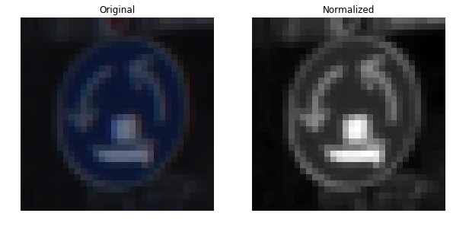

2. Describe what your final model architecture looks like including model type, layers, layer sizes, connectivity, etc.) Consider including a diagram and/or table describing the final model.

|  |  |
| --- | --- |
| Layer | Description |
| Input | 32x32x1 Grayscale image |
| Convolutional Layer 1 | 1x1 stride, VALID padding, output = 28 x 28 x 6 |
| RELU |  |
| Max Pooling | 2x2 stride, VALID padding, output = 14 x 14 x 6 |
| Convolutional Layer 2 | 1x1 stride, VALID padding, output = 10 x 10 x 16 |
| RELU |  |
| Max Pooling | 2x2 stride, VALID padding, output = 5 x 5 x 16 |
| Flatten | Output = 400 |
| Fully connected | Output = 120 |
| RELU |  |
| Fully connected | Output = 84 |
| RELU |  |
| Fully connected | Output = 43 |

3. Describe how you trained your model. The discussion can include the type of optimizer, the batch size, number of epochs and any hyperparameters such as learning rate.

I trained the LeNet with Adam optimizer with 0.001 learning rate, 128 batch size and 15 epochs. I initialized the variables with using truncated normal distribution of mu = 0 and sigma = 0.1, and using 0 for biases.

4. Describe the approach taken for finding a solution and getting the validation set accuracy to be at least 0.93. Include in the discussion the results on the training, validation and test sets and where in the code these were calculated. Your approach may have been an iterative process, in which case, outline the steps you took to get to the final solution and why you chose those steps. Perhaps your solution involved an already well known implementation or architecture. In this case, discuss why you think the architecture is suitable for the current problem.

Using LeNet Architecture and change the RGB image to grayscale image and finally output 43 classes. After 15 epochs, the training set accuracy is 98.5%, the validation set accuracy is 96.3 and the test set accuracy is 86%.

Test a Model on New Images

1. Choose five German traffic signs found on the web and provide them in the report. For each image, discuss what quality or qualities might be difficult to classify.



The first picture may be recognized as “turn left”. The second picture is very closed to other speed limit sign. When resizing the fourth one, the right angle will be converted to be less than 90 degree.

3. Describe how certain the model is when predicting on each of the five new images by looking at the softmax probabilities for each prediction. Provide the top 5 softmax probabilities for each image along with the sign type of each probability. (OPTIONAL: as described in the "Stand Out Suggestions" part of the rubric, visualizations can also be provided such as bar charts)

Image 1 is class 33 - Turn right ahead

Turn right ahead with predicted probability 39.9534195662

Roundabout mandatory with predicted probability 19.8304370046

Beware of ice/snow with predicted probability 19.2870661616

Ahead only with predicted probability 16.9018939137

Yield with predicted probability 2.89219226688

Image 2 is class 1 - Speed limit (30km/h)

Speed limit (50km/h) with predicted probability 51.6508936882

Speed limit (80km/h) with predicted probability 48.047876358

Speed limit (30km/h) with predicted probability 0.183911377098

Speed limit (100km/h) with predicted probability 0.0967613596004

Roundabout mandatory with predicted probability 0.0160190727911

Image 3 is class 25 - Road work

Road work with predicted probability 99.8853325844

Wild animals crossing with predicted probability 0.110197952017

Bicycles crossing with predicted probability 0.00444538854936

Slippery road with predicted probability 1.6426072591e-05

Road narrows on the right with predicted probability 1.32511090101e-05

Image 4 is class 12 - Priority road

Ahead only with predicted probability 86.255300045

Speed limit (60km/h) with predicted probability 12.4617442489

Speed limit (20km/h) with predicted probability 0.321626826189

Priority road with predicted probability 0.30255492311

No passing with predicted probability 0.240452215075

Image 5 is class 17 - No entry

No entry with predicted probability 96.0174202919

Turn left ahead with predicted probability 3.98162193596

Stop with predicted probability 0.000808570257504

Priority road with predicted probability 0.000121112805118

Beware of ice/snow with predicted probability 1.95929004576e-05